Hair and Makeup 2013-14 Annual Performance

BCDR Stage Make Up

Brand we recommend: E.L.F (Eyes Lips Face) – This brand is just a suggestion to give you an idea of the types of products we are looking for. Other brands may be used as well.

Eyes:

White Matte Eye Shadow
If purchasing E.L.F brand the color is called “Sand Dollar” #81121 cost: $3.00

Charcoal
If purchasing E.L.F brand the color is called “Charcoal” #81130 Cost: $3.00

Eye Liner
If purchasing E.L.F brand the color is “Black/Smoke” #81102 $3.00

Eyebrow Pencil
If purchasing E.L.F brand it is called “Eyebrow Lifter and Filler” choose a color that will best match your eyebrow and hair color $3.00

Black Mascara
If purchasing E.L.F brand it is called “Waterproof Lengthening & Volumizing” The color is black #81801 $3.00

Black Fake Eye Lashes (Tap Mini Line does NOT have to wear these)
If purchasing E.L.F brand it is called Dramatic Lash Kit Color Black #1714 $1.00

Face:

Skin Tone Foundation
If purchasing E.L.F brand pick a color that is close to your skin tone $6.00

Powder
If purchasing E.L.F brand it is called “Translucent Matifying Powder” #83101 $3.00

Rosie Blush
If purchasing E.L.F brand the color is called “Blushing Rose #83136 $3.00

A brush set to apply eye and face make up
If purchasing E.L.F brand it is called “Professional Complete Set of 12 brushes $12.00

Lip Stick:

“Heat Wave” by Nars purchased through the studio and will arrive by January.
ONLY COMPETITION STUDENTS PURCHASE LIPSTICK THROUGH THE STUDIO. Other students may purchase any red lipstick.

ALL BCDR

Please visit this link to watch a tutorial on how to make a bun: Please note that when Leah states “bobby pins” she means to say “hair pins” which are different (see pictures below) http://www.youtube.com/watch?v=kXTRT_ub3oI

Hair Products for Bun: ((Can be found at Target, Rite Aid, Walgreens)) *Brands shown are preferred for Quality*

- Spray Bottle –> Water 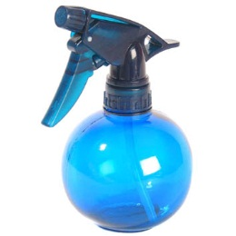

- ANY MAXIMUM HOLD Aerosol Hair Spray
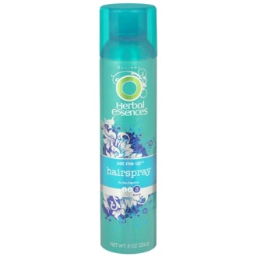

- Small Black Hair Ties

- 2-3 packs!!! Of Black or Brown Hair Pins by Conair—comes with thin and thick. The thick are the best and will not bend as easy.
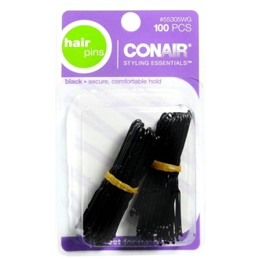

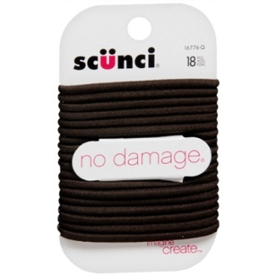

- Neutral Bobby Pins
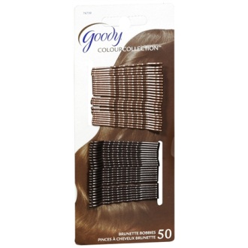

- Colored Hair Clips

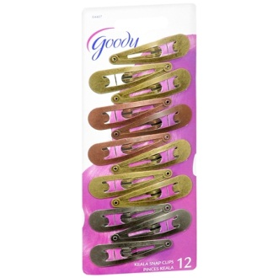

- Conair OR Goody Hair Nets—come in Black, Brown, Or Blonde for Hair Color Preference
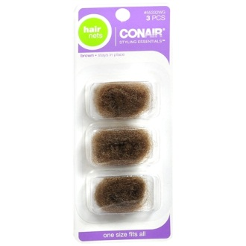

- Hair Gel – Strong Hold
